**ELECTIVE 3**

Midterm Exam

**Image Processing in Octave**

|  |
| --- |
|  |

Score

*Submitted by:*

**Bugarin, Justine Faith F.**

**3:00 pm – 4:30 pm / BS CpE 4 – 2**

*Date Submitted*

**24-11-2022**

*Submitted to:*

**Engr. Maria Rizette H. Sayo**

Methodology

1. Importing, Displaying, and Converting Images
2. Using the Editor of Octave, create a program that will load and display parrots.jpg
3. Examine the size of the parrots by typing whos to find out the size of the image that you have read in
4. Convert the class uint8 color image parrots to a gray scale image, and display the full intensity range gray-scale image using the imshow command
5. Covert the true color image to a gray-scale image
6. Save the program to this format parrots.m
7. Display of Color Images
8. Open the image file nature.jpg from the source folder
9. Read in the file nature.jpg and display it on the screen as a reference image How large an image is created when we use the RGB representation compared to a gray-scale image conversion of it?
10. Assign an image color that intensifies red, green, and blue and display each image in one window
11. Convert each image file extension to png
12. Save the program as nature.jpg

*Note: Take a screen shot of the output display of the converted images and do not forget to write your Octave code to this manuscript*

Screen shot of Output Image

1. Importing, Displaying, and Converting Images

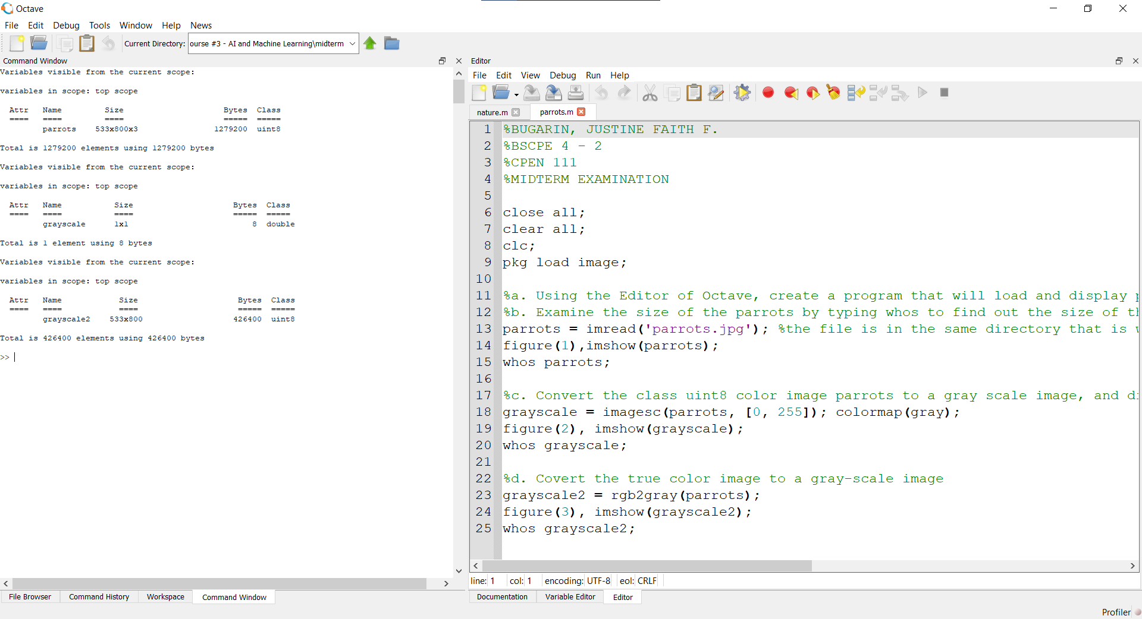

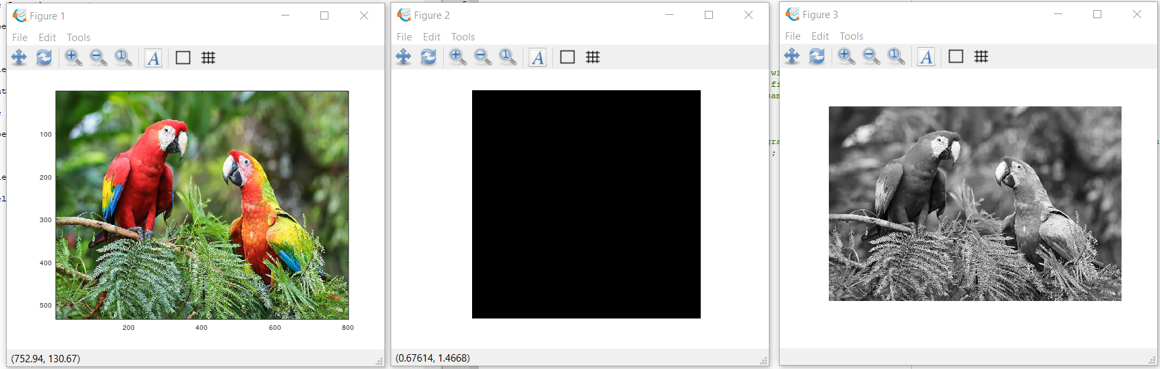

1. Display of Color Images

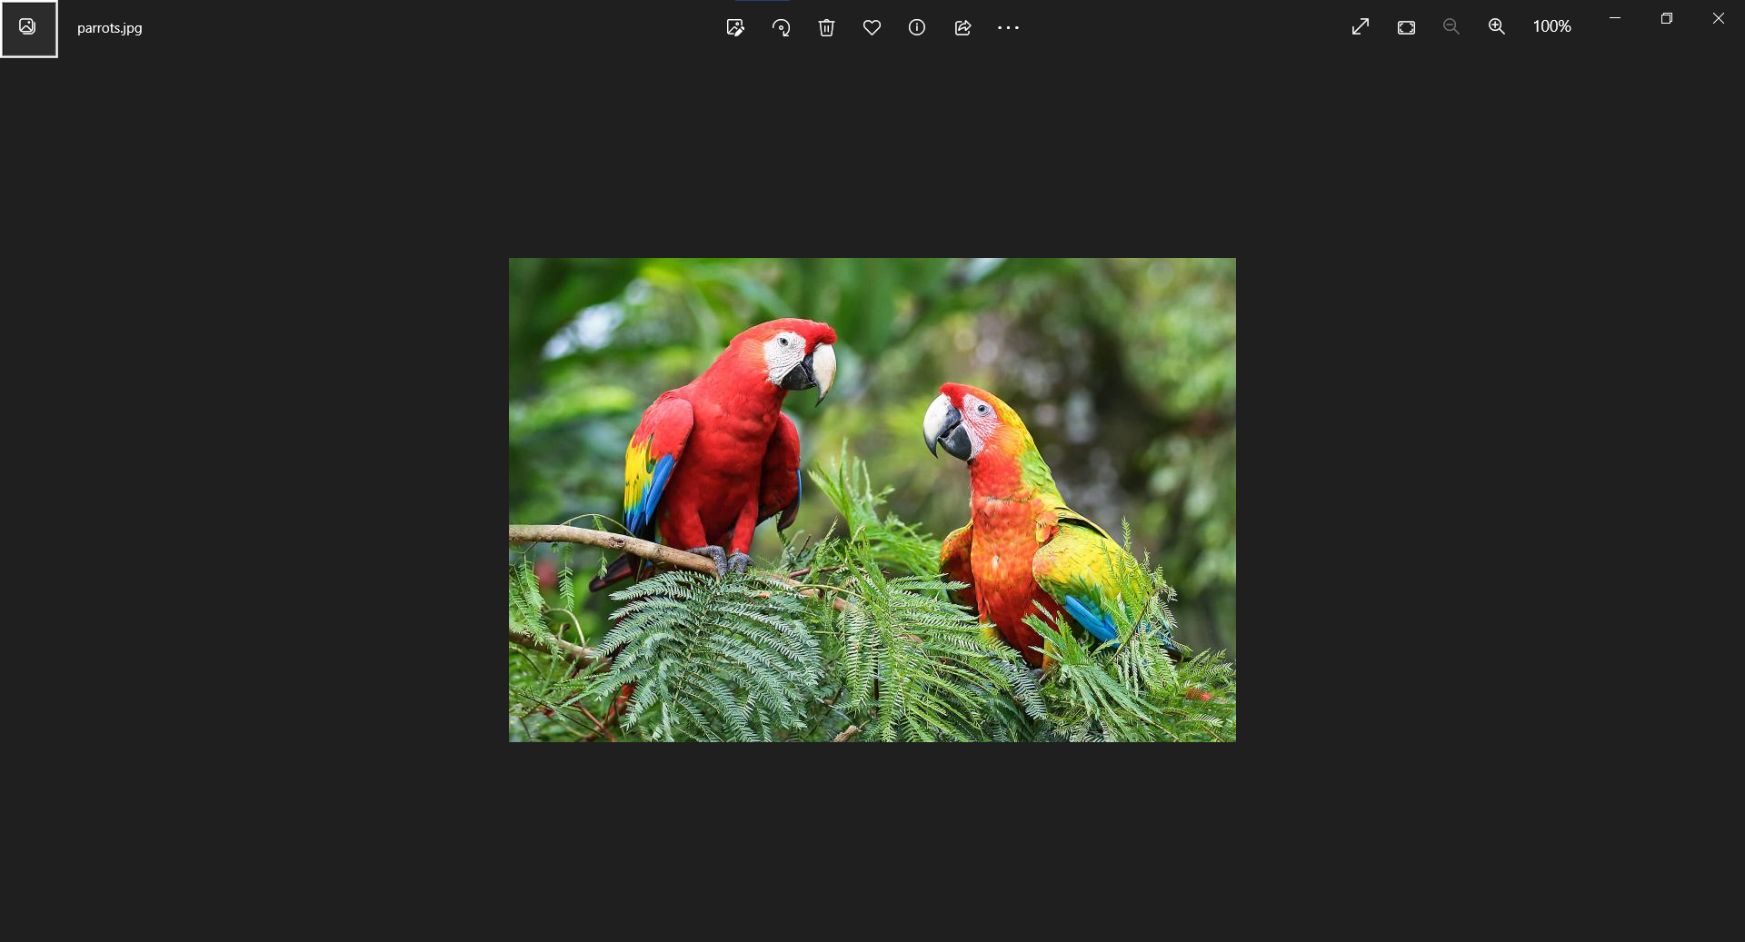

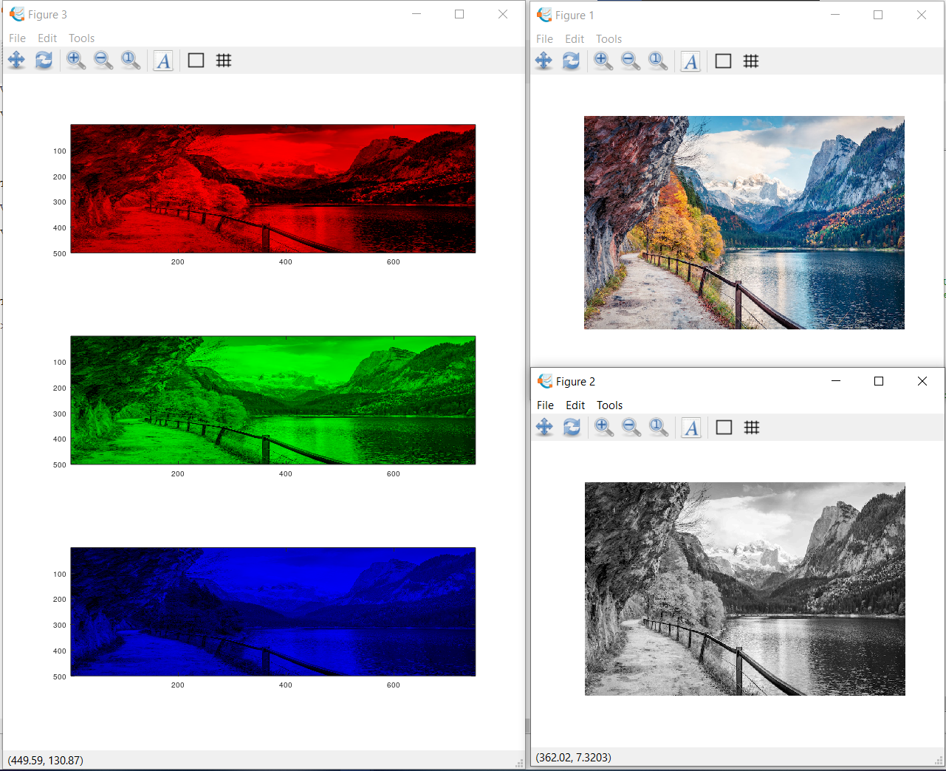

Source Codes:

|  |
| --- |
| 1. Importing, Displaying, and Converting Images   %BUGARIN, JUSTINE FAITH F.  %BSCPE 4 - 2  %CPEN 111  %MIDTERM EXAMINATION  close all;  clear all;  clc;  pkg load image;  %a. Using the Editor of Octave, create a program that will load and display parrots.jpg  %b. Examine the size of the parrots by typing whos to find out the size of the image that you have read in  parrots = imread('parrots.jpg'); %the file is in the same directory that is why i did not put the entire directory  figure(1),imshow(parrots);  whos parrots;  %c. Convert the class uint8 color image parrots to a gray scale image, and display the full intensity range gray-scale image using the imshow command  grayscale = imagesc(parrots, [0, 255]); colormap(gray);  figure(2), imshow(grayscale);  whos grayscale;  %d. Covert the true color image to a gray-scale image  grayscale2 = rgb2gray(parrots);  figure(3), imshow(grayscale2);  whos grayscale2; |
| 1. Display of Color Images   %BUGARIN, JUSTINE FAITH F.  %BSCPE 4 - 2  %CPEN 111  %MIDTERM EXAMINATION  close all;  clear all;  clc;  pkg load image;  %nature = imread('C:/Users/Justine Bugarin/Desktop/DOCUMENTS/COLLEGE/4th year/4th year (1st sem)/CPEN 111 - Elective Course #3 - AI and Machine Learning/midterm/nature.jpg'); %the file is in the same directory that is why i did not put the entire directory  nature = imread('nature.jpg'); %the file is in the same directory that is why i did not put the entire directory  figure(1), imshow(nature);  whos nature;  grayscale = rgb2gray(nature);  figure(2), imshow(grayscale);  whos grayscale;  %Assign an image color that intensifies red, green, and blue and display each image in one window  %red plane  img_red = nature;  img_red(:, :, 2) = 0;  img_red(:, :, 3) = 0;  %green plane  img_green = nature;  img_green(:, :, 1) = 0;  img_green(:, :, 3) = 0;  %blue plane  img_blue = nature;  img_blue(:, :, 1) = 0;  img_blue(:, :, 2) = 0;  figure(3), imshow(img_red);  subplot(3,1,1), subimage(img_red);  subplot(3,1,2), subimage(img_green);  subplot(3,1,3), subimage(img_blue);  imwrite(img_red, 'red_nature.png');  imwrite(img_green, 'green_nature.png');  imwrite(img_blue, 'blue_nature.png'); |

Conclusion

*In conclusion in this Midterm Practical exam, I have learned more in this exam because there are some commands that I haven’t explore yet. After this practical exam I have learned how to know the size of the image that I am manipulating, I also learned how to convert an image, how to display it using programming. How to manipulate an image into its full intensity etc. the new thing I learned in this examination is using displaying multiple image in a single figure. I learned that this is important in a lot of ways to minimize the the number of windows that will be used. Aside from this, I think it is important to learned all of this because this opened our mind how to manipulate images in a lot of ways, specially in programming, not just using apps and tools.*

Rubrics in Grading the Midterm Exam

|  |  |  |  |  |
| --- | --- | --- | --- | --- |
|  | A – Excellent | B – Good | C – Fair | D – Needs Improvement |
| Specifications | The Program works and meets all of the specifications | The program works and produces the correct results and displays them correctly. It also meets the most of the other specifications | The program produces correct results but does not display them correctly | The program is producing incorrect results |
| Readability | The code is exceptionally well organized and very easy to follow | The code is fairly easy to read | The code is readable only by someone who knows what it is supposed to be doing | The code is poorly organized and very difficult to read. |
| Reusability | The code could be reused as a whole or each routine could be reused | Most of the code could be reused in other programs | Some parts of the code could be reused in other programs | The code is not organized for reusability |
| Documentation | The documentation is well written and clearly explains what the code is accomplishing and how | The documentation consists of embedded comment and some simple header documentation that is somewhat useful | The documentation is simply comments embedded in the code with some simple header comments separating routines | The documentation is simply comments embedded in the code and does not help the reader understand the codes |
| Efficiency | The code is extremely efficient without sacrificing readability and understanding. | The code is fairly efficient without sacrificing readability and understanding | The code is brute force and unnecessarily long | The code is huge and appears to be patched together |
| TOTAL |  | | | |